|  |
| --- |
| Dear Sahil Sartaj , |
| Given below are the exit guidelines and information which will help you in completing the clearances activities smoothly. |
| [Click Here](https://ecms.fs.capgemini.com/) to log on to ECMS application or use this URL <https://ecms.fs.capgemini.com/> |
| * On the top panel of ECMS home page you can find a tab called Contact List to get in touch with departmental role holders to get your clearance completed * You can refer to FAQ document on ECMS home page, where most of your queries related to exit will be available.   + Exit Process FAQ - [Click Here!](https://km3.capgemini.com/system/tdf/asset/2020/09/03/Exit_Policy%20-%20Updated%20Sep%202020.pdf?file=1&type=document)   We also have an Orientation document, which will further guide you on the several sub-clearances and the timelines to complete the same.   * + Exit Orientation - [Click Here!](https://km3.capgemini.com/system/tdf/asset/2020/09/08/Exit%20Orientation.pdf?file=1&type=document) |
| Please do remember to update your **Personal Email id and Contact details in ECMS**, the same would be used for all future communications. |
| Relieving and Experience letters will be released on to your personal ID post completion of all the clearances (including the final clearance) without any dues. |
| **Employees having dues as part of exit checklist are requested to settle the same with exit team on Last Working Day** |
| Note - If total due amount is less than or equal to Rs.1000/-, Final Clearance will get auto cleared. Please do not make any payment. |
| **You need to obtain following clearances in ECMS** |
| |  |  | | --- | --- | | **Type of Clearance** | **Details** | | **Asset Management** | IT Asset Clearance will be provided **only on last working day** after all assets are surrendered / transferred. Timing for Asset exit/transfer clearance : **11 AM to 1PM**   Before approaching for clearance please ensure Laptops/Desktops, Safe word token, Black berry (as applicable) or any other IT assets needs to be surrendered by raising surrender ticket in India Service Desk portal at least 3 days prior to last working day.  Please ensure that you follow-up for asset surrender/transfer with the person handling your ticket.  For **Transfer of asset** (desktop/laptop) please initiate the process along with necessary approvals at **least 3 days before LWD** to avoid any delays/Hassles  IT Asset clearance will be provided only if asset(s) owned by you is surrendered/Transferred, ensure **asset is untagged** and your tickets is closed before approaching for clearance.  **NOTE:-** Please ensure while surrendering, the Laptop is in good condition. If any damage kindly get it repaired by raising request in Service Desk well in advance to avoid any last minute delay.   Recovery will be initiated if surrender asset is in damaged condition.   **"As a process, without following above mentioned steps, it would delay your clearance.**  **" Kindly refer below process document for Desktop/Laptop Transfer and Surrender available in Talent portal:**  [Laptop Allocation, Transfer and Surrender Process](https://talent.capgemini.com/media_library/Medias/ITICS_Hub/Laptop_Allocation__Transfer_and_Surrender_Process.pdf)  [Desktop Allocation, Transfer and Surrender Process](https://talent.capgemini.com/media_library/Medias/ITICS_Hub/Desktop_Allocation__Transfer_and_Surrender_Process.pdf) | | **EIS/HR Clearance** | EIS/HR clearance will be done 2 days before LWD, notice period shortfall days will be updated in ECMS 1 day before LWD. Please contact the location POC as mentioned in contact list available in ECMS home page | | **Supervisor Clearance** | Your Supervisor has to provide the clearance in ECMS, this is in addition to his approval for resignation  Time sheet for preceding 180 days and expense clearance if any, has to be approved by supervisor before LWD | | **Finance** | Please connect with Finance team 7 days prior to your last working day.   **Forex** - If you have any Onsite travel you need to get in touch with Forex team to verify your record by providing them your relevant documents like LOA, Per Diem Annexure Form and Passport Immigration along with stamps having your travel period mentioned in it or else Project Manager s e-mail approval.   **Please get your record verified with forex team in case you have claimed Travel Kit Allowance or Relocation Cost.**   The same is not applicable for employees on Transfer.   **Payroll It is mandatory to upload investment proofs in Payroll (HGS) 3 days before LWD, if applicable.**   Proof submitted on emails will not be **Accepted** for FnF settlement | | **Insurance** | |  |  |  | | --- | --- | --- | | **S.No** | **Plan Name** | **In the event of separation from Company** | | 1 | Voluntary Parental Insurance Policy | In the event of separation from Company | | 2 | Group Medical Insurance Policy | Policy gets cancelled retail policy to be initiated 45 days before last working day for continuity benefit |   If an employee is interested, they can opt into a retail plan for self, spouse children and for parents with continuity benefits. Below are the details on the same. **Voluntary Medical Insurance Continuity:**For Continuity benefit on retail insurance plan in India for Employee, Spouse and Children This plan can be opted under following scenarios: 1. Employee deputed for long term assignment (more than 1 year) or  2. Employee is planning to retire  3. Employee exit Capgemini  Waiting period as per retail will be waived upto the tenure of employee in Capgemini India medical insurance plan.   **Voluntary Parental Insurance Continuity :** Employees who have enrolled for the voluntary parental plan in the previous 2 years before exiting the organization can opt for retail plan in India for Parents This plan can be opted under following scenarios: 1. Employee is planning to retire  2. Employee exit Capgemini  Waiting period as per retail will be waived upto the tenure of employee in Capgemini India Voluntary Parents insurance plan.  **Important Points** The current Voluntary Parental Insurance plan, if opted, will continue to remain active till the policy expiry date mentioned on the e-card. **No cancellation** to the Policy is allowed during the year post subscription to the plan. In case the employee is leaving the organization then the balance premium has to be paid by the employee on or before LWD. To avail continuity benefit on GMC, request should be raised 45 days prior the LWD in Capgemini India and for Parental Insurance request must be raised 45 days prior to Policy expiry date. Pre-medical check may be required depending upon age of insured persons  The coverage and premium will be as per retail plan and not as per Capgemini offered plan.  Anyone interested can connect with <capgemini.continuity@aon.com> to enroll for the plan. Escalation point incase of no response <minaxi.sharma@aon.com> or <anuradha.bose@aon.com> | | **ICRES** | **ID & Access Card:**   **ID card needs to be submitted by all employees mandatorily**  ID card should be **submitted to the ID card cell in the respective locations by 3 pm**  If the ID card is **not submitted within the LWD a penalty** will be levied  The ID card cell will issue visitor pass to exiting employees once they submit their ID s.  The pass is valid only on the LWD.  The pass will allow the employees to remain in premises to complete their formalities. He will be escorted to access any of the work area (N+1 or anyone who is authorized by N1). | | **Amex card** | **AMEX Card:**  Clearance will be given 10 days before LWD for employees who are not holding Corporate AMEX Card  Employees holding Corporate AMEX Card and having any dues are requested to settle it directly with AMEX vendor  Clearances will be given only if the account shows 0 balance  **Note: To speed up the clearance process, kindly share the screen shot of payment details with Amex help desk team** | | **Learning and Development** | **L&D Library**  Auto clearance is provided in case you do not have any books  Books should be returned **at least 45 days** prior to the last working day  For any queries or concerns, please contact Library SPOC  **L&D certification**  Please get in touch with the L&D certification clearance role holder 7 days before LWD   L&D role holders names are available on ECMS - Contact list  **Note : Training cost recoverable is updated by the L&D team in amount section.** | | **People Process (HR)** | Please ensure to update all the availed leaves in LMS and Clarity / Time card (time sheets) with appropriate leave code.  This should also be approved by your supervisor at least 3 days prior to the last working day.  **People process clearance shall be auto cleared prior to 2 days/1 day or on Last working day subject to completion of Time helpdesk clearance.**  **In case time helpdesk clearance is pending, People process clearance shall be auto cleared on Last working day.** | | **Time Helpdesk** | ACIS employees needs to ensure that in **India Timecard Application Portal, last 6 months (till the LWD of ACIS employee)**timecard status should be in **Approved** status. Post which Supervisor can provide Time clearance in ECMS portal.  1.In case of any **technical** related queries in **ECMS portal** raise the ticket through ITSM Portal : **Service Central Click on Browse categories Employee Management- ECMS- Select appropriate category** 2. In case of any **technical** related queries in **India Timecard Application Portal** raise the ticket through ITSM Portal: **Service Central Click on Browse categories Finance Applications Timecard(Finance) - Select appropriate category**  **BSv employees** should ensure that all the **Timesheets are approved by Supervisor till the LWD** in Replicon system for any issues related to time helpdesk clearance please reach out to CORP, Bsv Helpdesk [bsvhelpdesk@capgemini.com](mailto:bsvhelpdesk@capgemini.com)  **.Note:** Supervisor Clearance is mandatory to provide Time Helpdesk clearance  In case of any **technical or functional** related queries in **Replicon Portal** raise the ticket through **Service Central** in the below path- **Talent – About Us – Global Business Line (GBLs) – Business Services India - Global Time Management (Replicon) BSV India** | | **BU HR Clearance** | BU HR Clearance:  BU HR clearance can be given 7 days before the LWD.  Details of the BU HR are available on Exit request status tab in ECMS | | **Car Lease** | Auto clearance is provided in case you do not have any car loan and there is no need for you to follow up for the same. If you are having any Active Car loan, then pls connect with the car lease co-ordinator to check on the due amount and the process to close the lease ([clcprocesscoordinator.in@capgemini.com](mailto:clcprocesscoordinator.in@capgemini.com)) For any queries or concerns, please contact car lease role holder names as available on ECMS - Contact list Note : Car lease amount recoverable is updated in the amount section. | | **Mobility/IAS Clearance** | Mobility / IAS:  Clearance can be completed 7 days before last working day if you do not hold any visa s Please get your record verified with IAS / Mobility team, in case you hold valid Work Permit / Visa / Residence Permit Card  For any queries or clarification, please contact IAS / Mobility admin as mentioned in contact list. | | **Gratuity** | Upon validation of the record, the claim will be processed and disbursement of the amount will be settled through your salary a/c within 30 days from your LWD.  For helpdesk support, please write it to the email-id :[retiralshelpdesk.in@neocasemail.com](mailto:retiralshelpdesk.in@neocasemail.com)  **Note:** You should mention your **entity and employee-id** whenever you communicate to the helpdesk team for better tracking. | | **Provident Fund(PF)** | **KYC:** We request you to update your name as per Aadhaar in UAN Member Portal on EPFO site :  <https://unifiedportal-mem.epfindia.gov.in/memberinterface/>  Please note this requirement is mandatory from PF authority to complete the individual KYC to avoid any issues in future.  For any queries related to your PF account (including PF withdrawal/Transfer), please get in touch with the PF team :  For helpdesk support, please write it to the email-id :[retiralshelpdesk.in@neocasemail.com](mailto:retiralshelpdesk.in@neocasemail.com) | | **Escalation Matrix** | If the query is not resolved within 3 working days, please write it to :[retiralshelpdesk.in@neocasemail.com](mailto:retiralshelpdesk.in@neocasemail.com)  If the query is not resolved within 15 working days, please escalate it to : [arunkumar.gopalakrishnan@capgemini.com](mailto:arunkumar.gopalakrishnan@capgemini.com) | |
| **Shift and On Call Allowance Process:** |
| * 1- Please ensure that you raise your Shift and On-call allowance before your Last Working day. Any shift or on-call not claimed via the tool will not be processed. * Please note that your attendance and roster are updated on the tool. Once the details are updated you can raise a shift/on-call claim on the tool. Any changes to empulse records will take 48 hours to reflect on the shift allowance tool hence ensure you plan before your last working day. |
| **In case of queries, please reach out to:** |
| * 2- For technical queries please raise a ticket on <http://help.capgemini.com> -> Finance Application ->Shift Allowance. * 3- For payment related queries please raise a ticket on <http://help.capgemini.com> -> Finance Applications -->PICS (Finance). * 4- For change in approver definitions - <http://help.capgemini.com> -> Finance Support-->Project Player Definition-->New PM Matrix definition * 5- For policy or process understanding related query please reach out to your BUHR |
| **Full and Final settlement Process:** |
| Full and final settlement shall be credited within 45 days from your final clearance completion date. |
| **Please note** - If the last working date is on or before the 5th of any month, the previous month s salary will be put on hold and will be paid along with the full & final settlement |
| *For instance - If your last working date is 1st/ 2nd/ 3rd/ 4th/ 5th Aug, your Jul month salary will be kept on hold and will be paid out with your Final settlement.* |
|  |
| Note: GetSuccess is available for performance management, if you have queries please write a mail to [tmsupport.global@capgemini.com](mailto:tmsupport.global@capgemini.com) |
| Please do not reply directly to this email as this is an automated email and will not acknowledge any responses made directly to this message. |
| Regards, HRSS Offboarding Team |

SpeakUp: <https://www.capgemini.com/speakup>

Project Code: 100378129

New Project Code: 101054707

Cloud Doubt: sanket.suresh-parinchekar@capgemini.com

Sapience Doubt: akshada.gawade@capgemini.com

Credly, MediBuddy: Sartaj123@#

AWS: Amr10@_;

Bench Internet Expense: 100751975

PrintStop Brand Store: Sar123@

PostgreSQL: pswd: 123456

IKEA Code: 100703398

Internet Bill: 100751975

 ID Card: [koushik.mitra@capgemini.com](mailto:koushik.mitra@capgemini.com) or [soma.a.mukherjee@capgemini.com](mailto:soma.a.mukherjee@capgemini.com)

r2d2: <https://r2d2-tools.capgemini.com/Home/Index?ggid=46132436>

------------------------------------------------------------

Admin Supervisor: Shilpa V (  SHILPA.A.V@CAPGEMINI.COM )

Performance Reviewer: AnilKumar BR (  ANILKUMAR.BR@CAPGEMINI.COM )

HRBP: Latika Vijay Shetty (  LATIKA-VIJAY.SHETTY@CAPGEMINI.COM )

Resource Manager: Vishal Patel (  VISHAL.I.PATEL@CAPGEMINI.COM )

Learning Partner / Training Approver: Shilpa V (  SHILPA.A.V@CAPGEMINI.COM )  
------------------------------------------------------------------------------------

Websites

<https://indiaapps.in.capgemini.com/Aspxpages/Applications.aspx>

<https://iconnect.fs.capgemini.com/>

<https://builders.capgemini.com/readcommunicationonline?content_id=A4E8C5C9-4347-4AC4-6FFF-556544AD24EE>

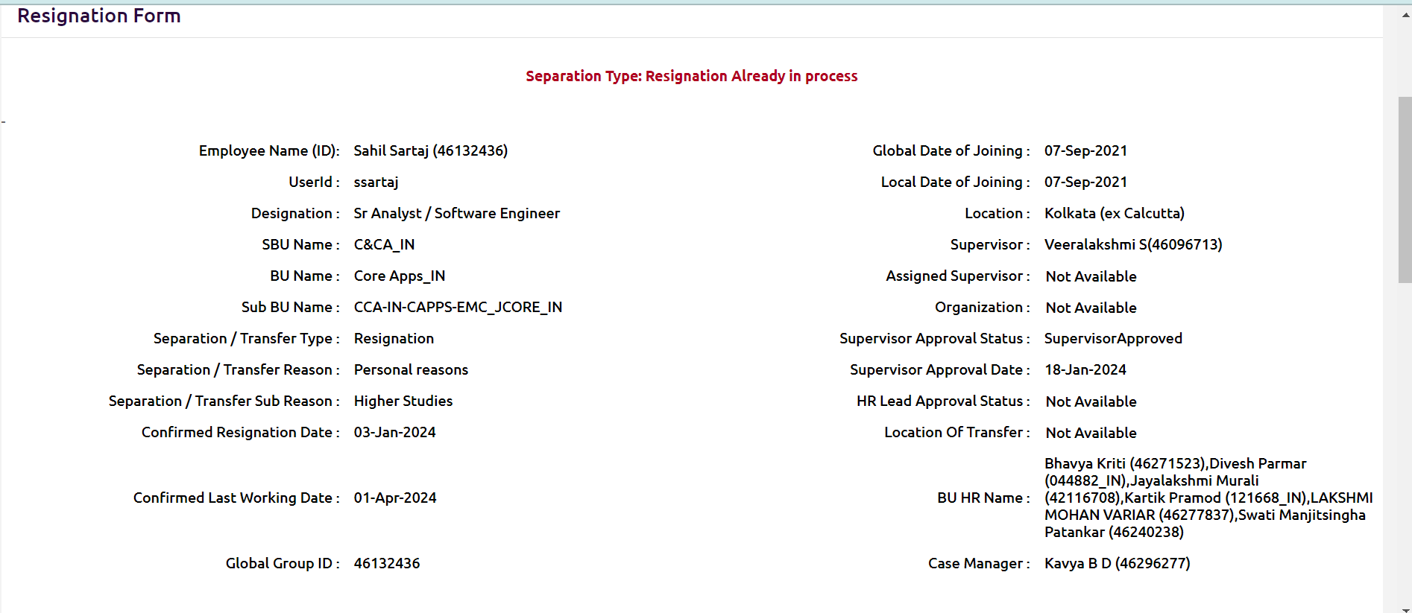

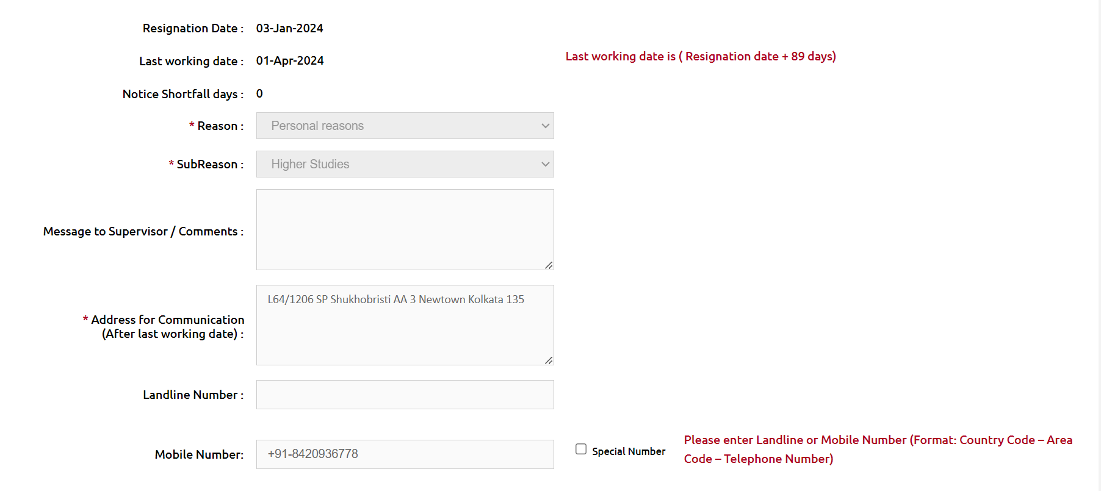

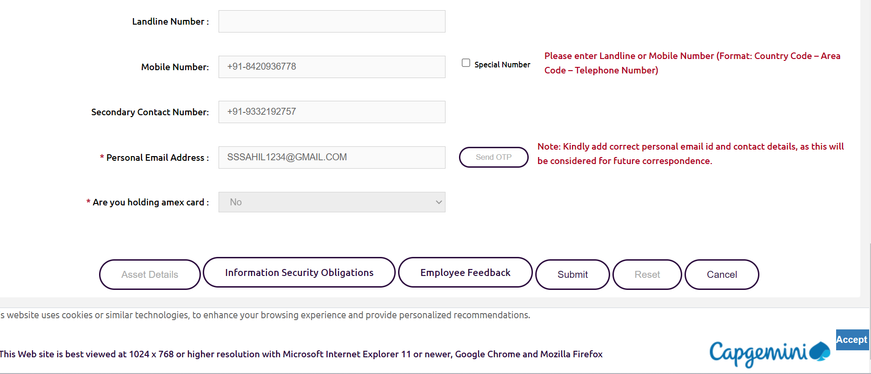

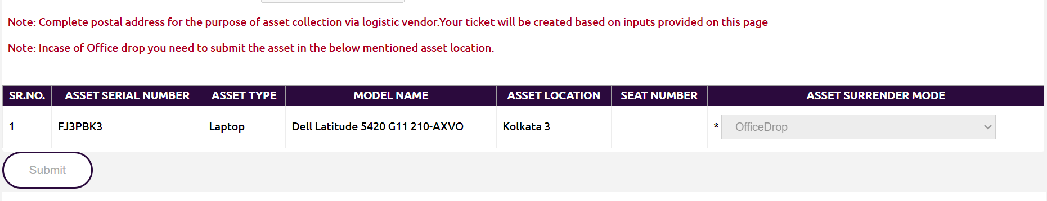

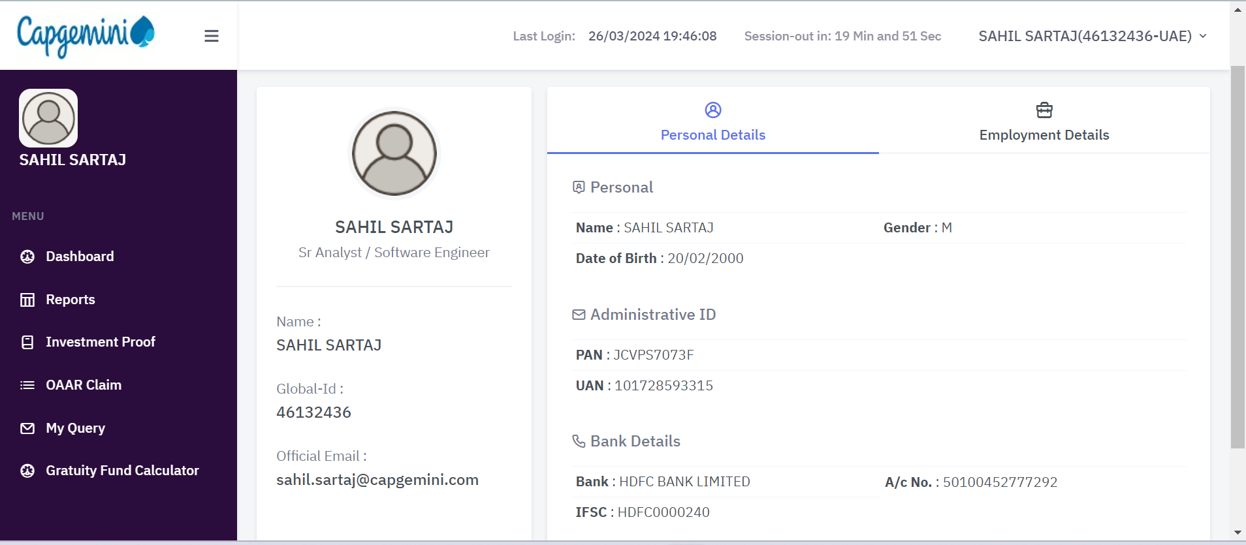

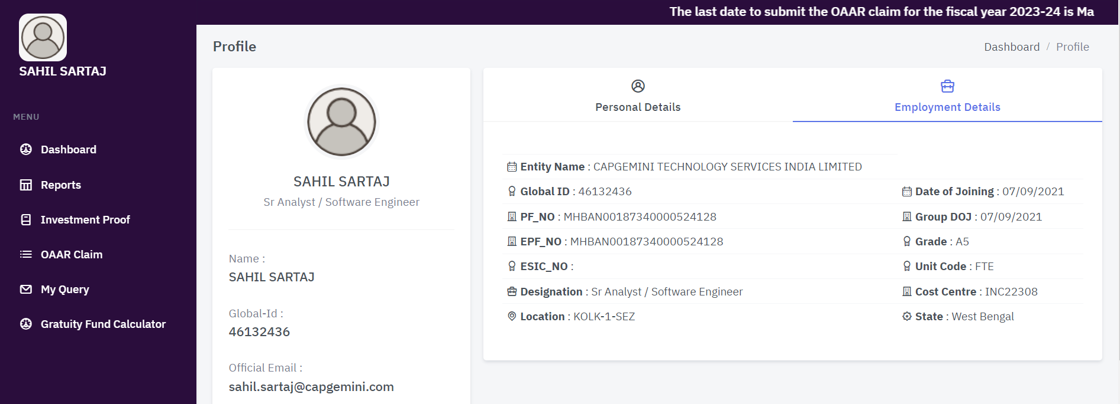

Dear Colleagues,

As a part of the Relieving process, India Payroll team would be giving the Finance Payroll Clearance in ECMS Tool One week in Advance prior to your last working day.

Kindly make sure that all other teams have given their clearances before your last working day in ECMS Tool, so that, there is no delay in starting your final settlement process.

Final settlement will be initiated post all the clearances are done.  Any delay in clearances would further delay the final settlement process.

Final settlement will be completed and the amount will be transferred to your Bank account within 30 days from the last clearance date in ECMS Tool (Not last working day)

Reach out to [Fnfhelpdesk.in@capgemini.com](mailto:Fnfhelpdesk.in@capgemini.com) for any further clarifications on Final Settlement.

Refer the [Exit Orientation presentation](https://talent.capgemini.com/viewer.html?file=/getDocs/415C403A-BAAB-09AA-6761-28E2A6A1423A/Exit_Orientation_Slide.pdf) about Final settlement / Exit process on Talent India - Finance home page.

Additionally, do join the Exit Orientation program organized by the ECMS Exit team. Weekly sessions are held on Tuesday, Wednesday, and Thursday from 3:00 pm to 5:00 pm.

**Key Important points to be noted:**

Complete the below activities before your last working day.

1. **Clearances**
   1. Ensure that all the other teams have given their clearance. Final settlement can be initiated only post all the clearances.
2. **Leave Encashment Days**
   1. Do check your leave balances with HR team at the time of HR clearance.  Any corrections in leave balances to be discussed with HR and closed before last working day.
3. **Submission of OAAR & Investment Proofs**
   1. Submit your OAAR claims and Investment Proofs, if any, into HGS Portal before 3 days prior to your last working day
   2. Proof submitted on emails **“Will Not be Accepted”** for Final Settlement
4. **Payment to Company towards Joining Bonus, Retention Bonus, Notice Pay**
   1. Employees are required to settle the Joining Bonus, Retention Bonus, Notice Pay upfront
   2. Exit team would be sharing the Company Bank Details for transferring the funds.  Employee to do Online transfer (NEFT / RTGS Only) and share the screenshot with Exit Team for their Clearances.
   3. These recoveries (Joining Bonus, Retention Bonus, Notice Pay) will not be adjusted against the Full & Final Settlement
5. **Any Other Allowance (Shift / On-Call Allowances)**
   1. If you are eligible for other allowances like Shift/On-call allowance etc., kindly ensure that  your Manager has uploaded and approved the same into PICS tool before your last working day
   2. No Manual inputs will be accepted
6. **HGS Login Credentials**
   1. Reset your HGS Password before moving Out.
   2. You can access the HGS Portal even after leaving the Company and access will be retained for you for the period 1-2 years.
7. **Personal Email IDs and Mobile #s**
   1. Kindly ensure that your **personal Email ID’s & Mobile #’s** are updated in ECMS tool. This is required for future communication (From16). **This is Mandatory**.
   2. Forgot HGS login password post last working day – You can reset the same on your own.  Ensure, correct personal email ID is updated in ECMS tool.
8. **Pay-slips and Form 16s**
   1. Download the required previous month’s pay-slips and previous years Form 16s.  **This is Important**.

**Kindly ignore this mail if you have already taken action on this email.**

**Regards,**

**Finance – India Payroll Team**

**PF/Gratuity** : For PF/Gratuity related queries please drop in a mail only to [retiralshelpdesk.in@neocasemail.com](mailto:retiralshelpdesk.in@neocasemail.com%20)